Fields and Application Instructions
First screen, select the invitation you wish
Second screen, select the position of the invitation that you are interesting for
Third screen, fill in the personal data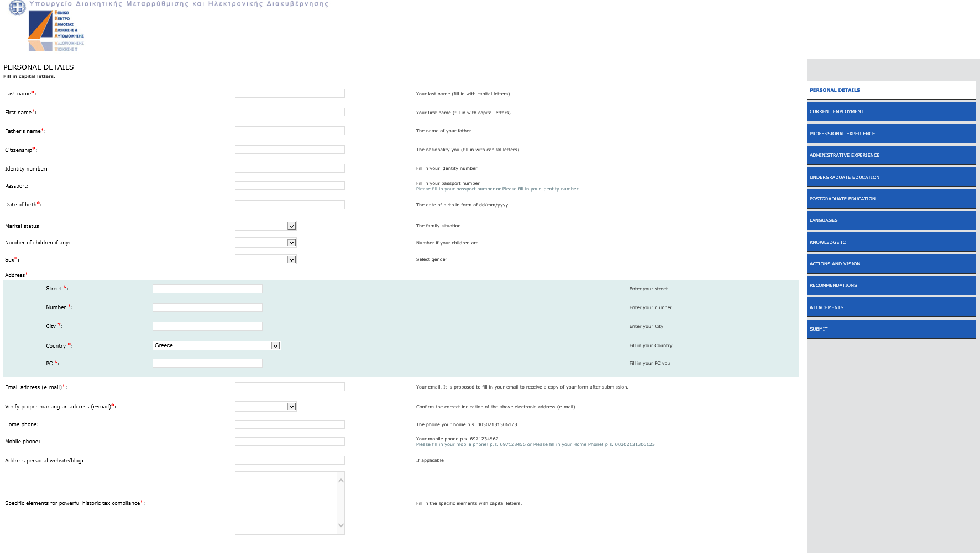

Forth screen, fill in the data for your current occupation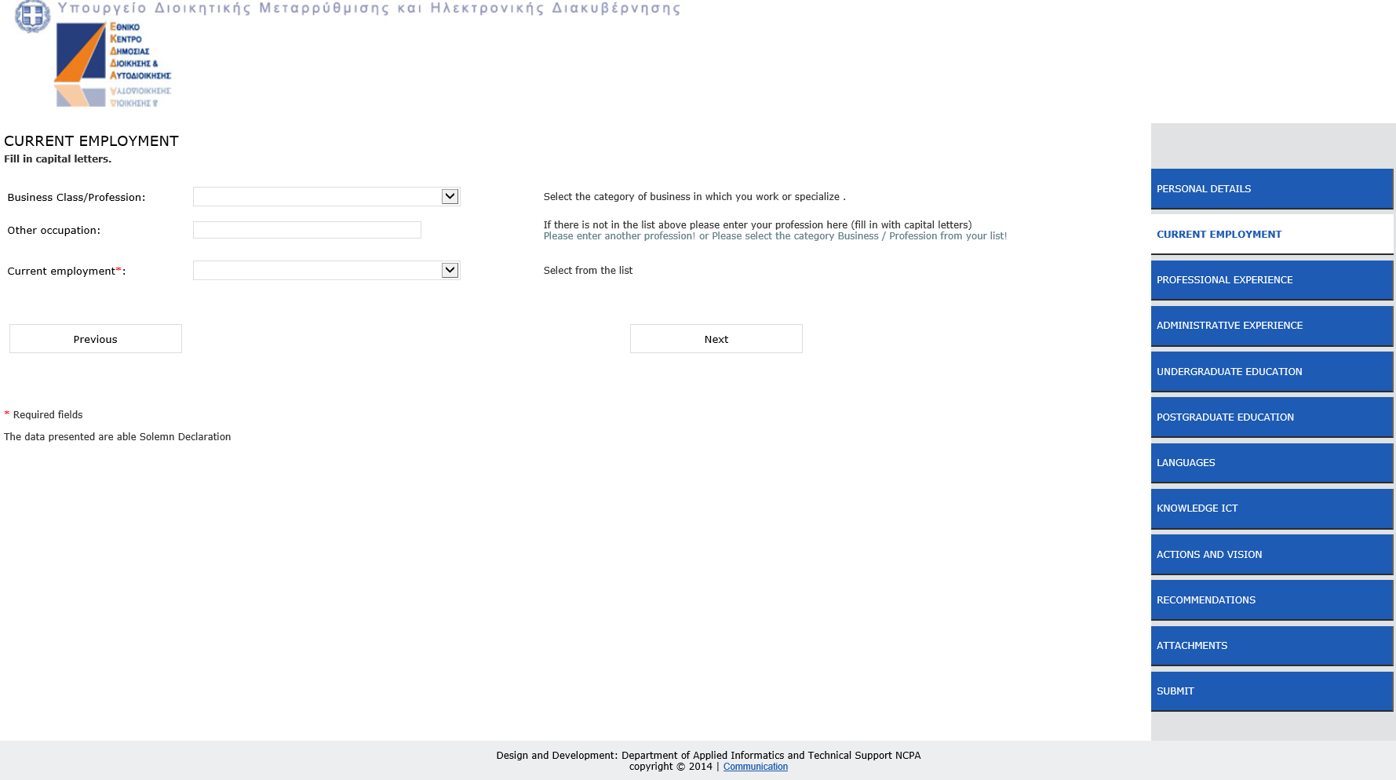
Fifth screen, fill in the data for the occupational experience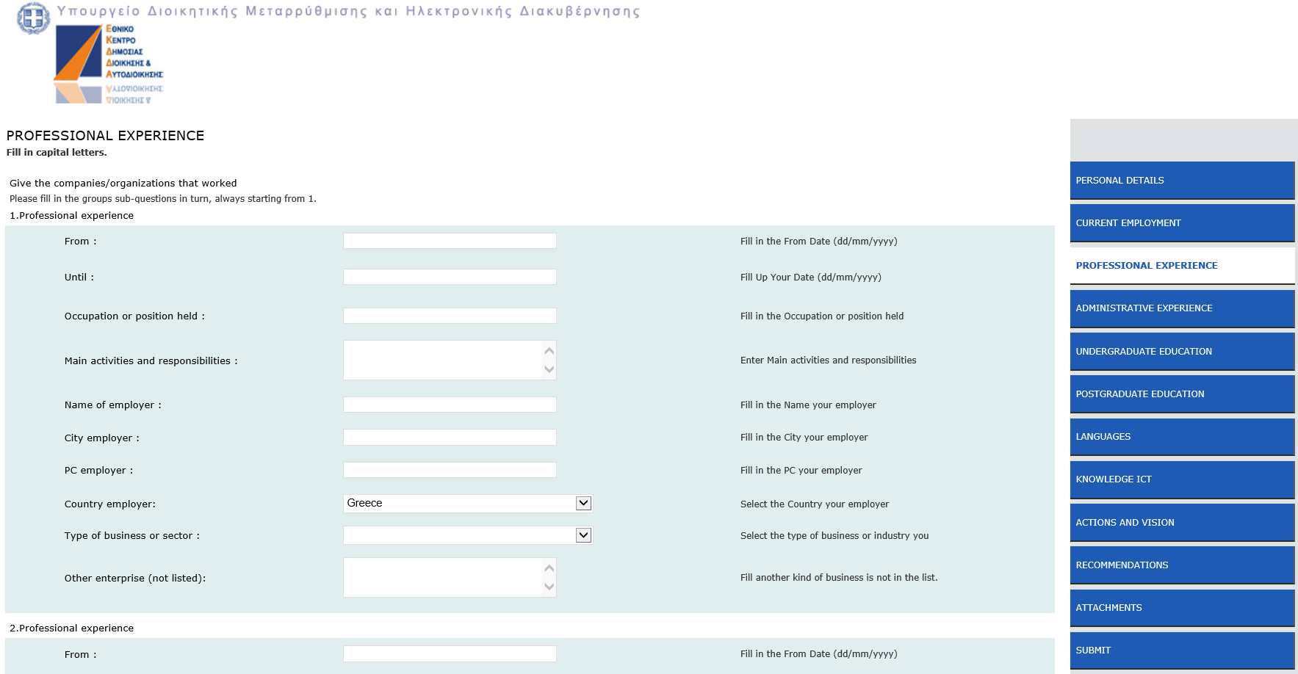
Sixth screen, fill in the data for the administrative experience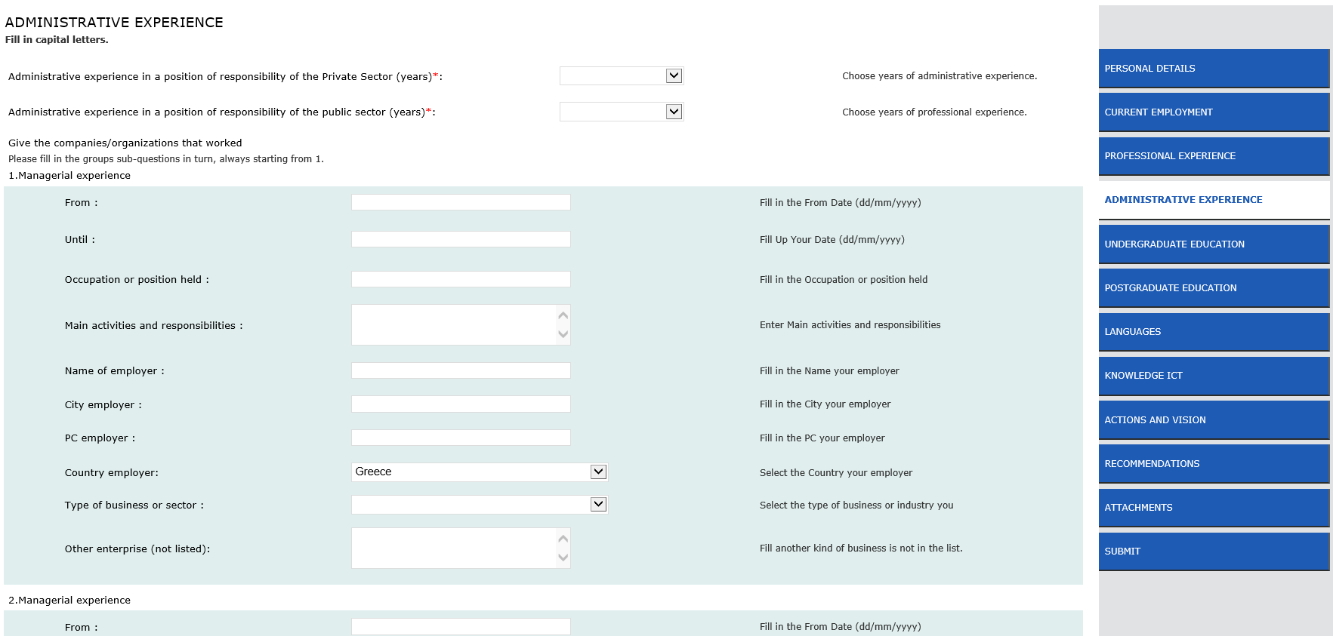
Seventh screen, fill in the data for the under graduate education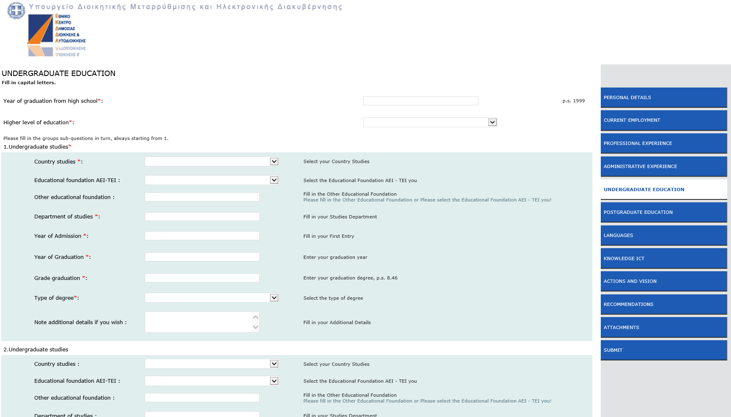
Eighth screen, fill in the data for the post graduate education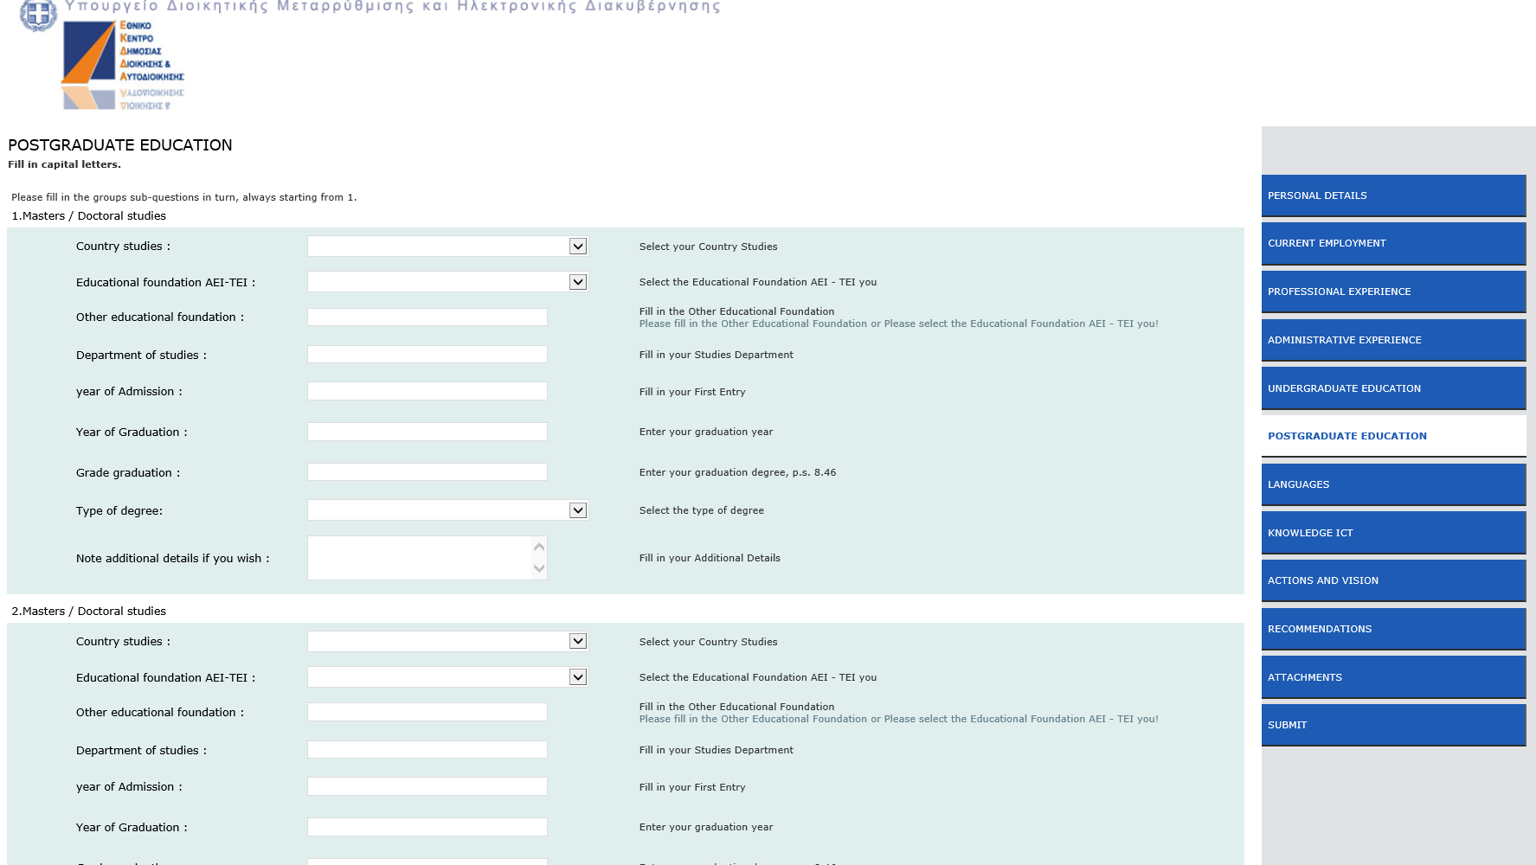

Ninth screen, fill in the data for the languages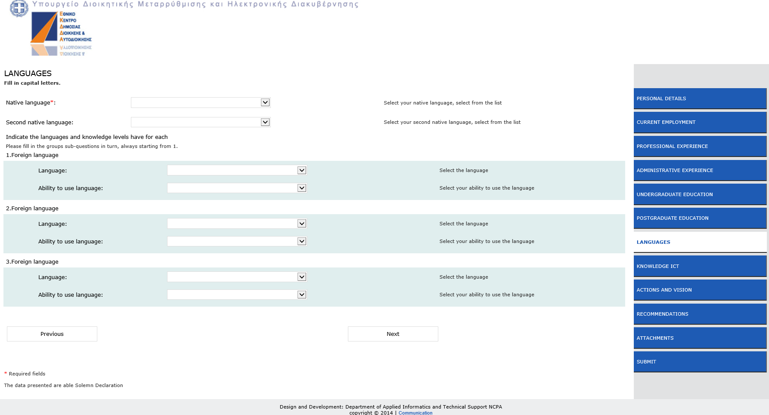
Tenth screen, fill in the data for ICT knowledge
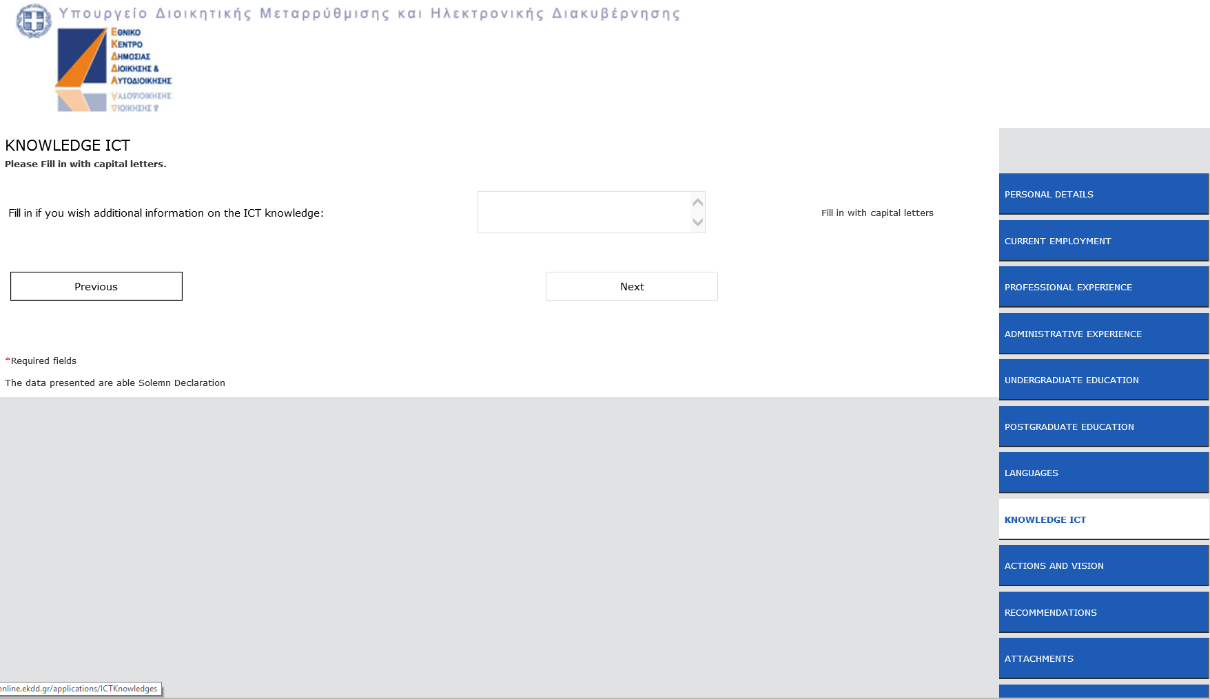

Eleventh screen, fill in the vision and the social activities
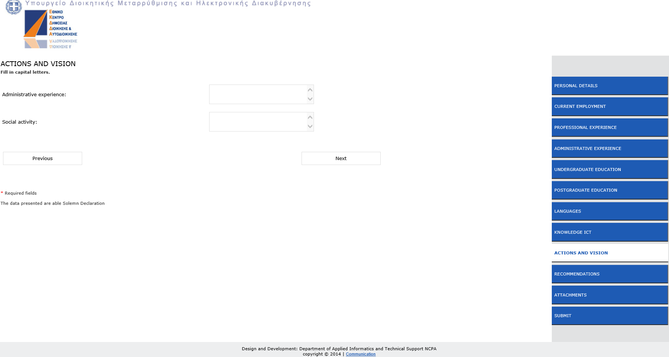
Twelfth screen, fill in the recommendations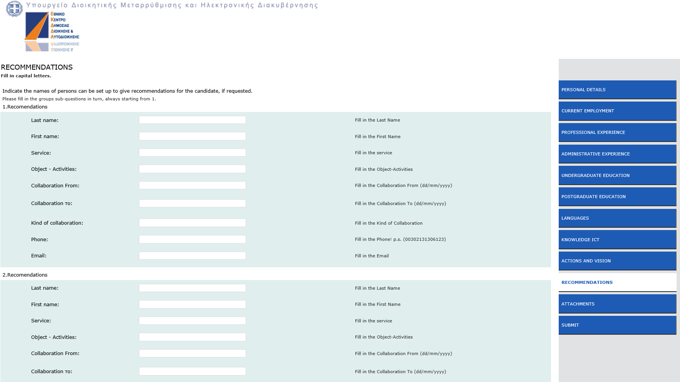
Thirteenth screen, upload one file with needed data, acceptable file types .zip and .pdf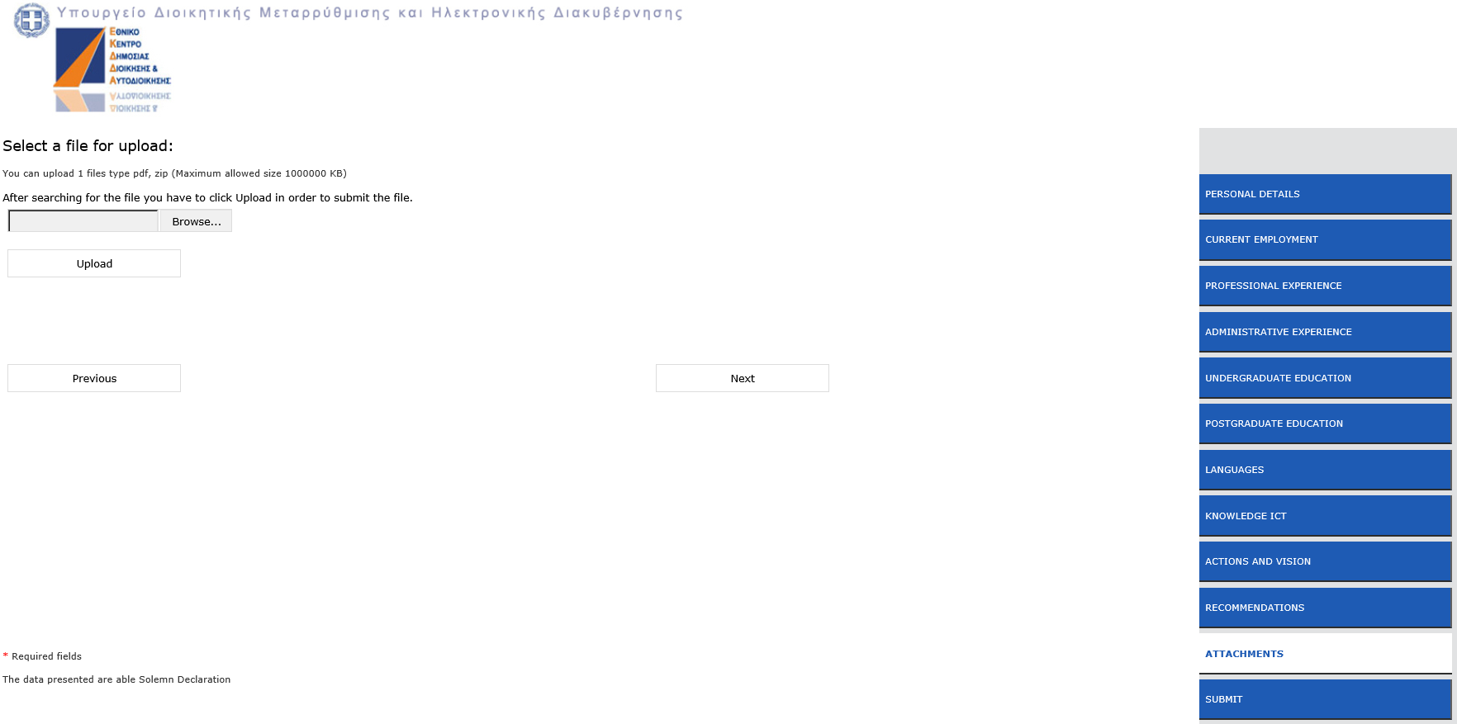Fortieth screen, read the conditions before you submit, view and print (if you wish) the draft application, submit the application.